**Brooklyn torah gazette**

**For parshas Ki Seitzei 5779**

Volume 3, Issue 53 (Whole Number 150) 14 Elul 5779/ September 14, 2019

**Printed L’illuy nishmas Nechama bas R’ Noach, a”h**

For a free subscription, please forward your request to [***keren18@juno.com***](mailto:keren18@juno.com)

**The Command to**

**Return to Hashem**

**By Daniel Keren**



The second speaker at last week’s Flatbush Hakhel Yarchei Kallah program was Rabbi Elya Brudny, rosh yeshiva of the Mirrer Yeshiva in Brooklyn. He began by pointing out that the Shaare Teshuva, Shulchan Aruch on Rosh Hashanah brings the custom that after mincha, the gabbai approaches the bima and declares Shuvu Banim (Return you children.)

This refers to the verse read in the Torah reading that we are Banim (children) to Hashem. And it is a greater love of Hashem to us that He made it known to us that He regards us as His children.

This means that we should keep this important concept in mind when difficulties and challenges frequently arise in our lives and realize that Hashem brings them upon us in the same manner as loving father who chastises his child [not to punish him but for that child’s ultimate benefit.]

We are banim (children) and Hashem [whether through a human teacher] connects to us through His Torah and our efforts to learn it. Rashi declares that this creates and reinforces our relationship of being banim atem to Hashem.

**Understanding that Life’s Difficulties are for Our Benefit**

Therefore this should help us to internalize that life’s difficulties are for our benefit to make us appreciate Hashem’s role as Avinu, our Father [in Heaven]. And this can only be accomplished through our limud haTorah (study of the Torah.)

Rosh Hashanah is quickly approaching. How are we too comprehend the awesome significance of this day? Only by making an effort to Shuvu Habanim to Hashem (return ourselves as children to Hashem) by burdening ourselves with more Torah learning. For that is the way Hashem communicates with us by our learning the Torah [He gave us at Har Sinai.]

Even before Chodesh Elul and the sounding of the shofar whose purpose is to wake us up from our spiritual slumber, Hashem is rebuking us with news of terrible tragedies, of those who died saving kids from drowning and others who died in water park disasters.

How can we afford to chuckle when hearing about Category 5 hurricanes bearing down on land at murderous 180 miles per hour speeds and just shrug it off as Mother Nature?

**Did We Take Heed of Hashem’s Messages to Us?**

Did we take heed when hearing about tornadoes destroying towns in the Midwest or forest fires out of control in the West or mud slides wiping away many homes of the rich in California? It was Hashem who made the horrifying sniper shootings in Las Vegas or the mass gun killings in Florida. But we don’t get these messages because we erroneously shake it off as a right wing or left wing lunatic.

We are like a child who during the travails of a terrible war was separated from his father and only as a teenager or as a 30-year old manages to return home. He doesn’t understand the feelings of his loving father.

We are Rabbi Brudny said as banim li Hashem only able to reconnect to our Father in Heaven by strengthening our Torah learning, which is our spiritual oxygen. If we are low on oxygen or Torah learning, we are unable to perceive Hashem’ messages to us. In such a catastrophic situation what is Rosh Hashanah or Yom Kippur going to help us unless we strengthen our learning and keeping a solid schedule of shiurim (lectures) and chavrusos (learning partners.)

**A Clarion Call for All of Us to Wake Up**

This is a clarion call for us to wake up. One cannot remember such a summer like this in which every day brought us catastrophic news about members in our community [dying or seriously getting injured). If we are in a deep sleep by ignoring the obvious lessons that Hashem wants us to hear, we are in serious trouble.

The Maharsha said that without the Torah, one is a subhuman. We are in the beginning of a 40-day process leading to Yom Kippur. We must utilize this opportunity by dedicating ourselves more seriously in limud haTorah and thereby better understanding the “hurricane” messages and not needing more painful internal messages. We use this opportunity of Chodesh Elul to come closer to Hashem and thus be worthy of being blessed with a good Gmar Chasima Tova this year.

*Reprinted from this week’s edition of the Flatbush Jewish Journal.*

**The Mother Bird and Amalek**

**By Rabbi Eli J. Mansour**

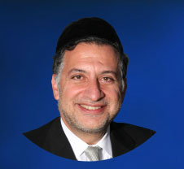

The Torah in Parashat Ki-Teseh presents the Misva of Shilu’ah Ha’kan, which requires sending a mother bird away from the nest rather than taking it together with the eggs. One of the unique features of this Misva is that it applies only when one chances upon a bird’s nest.

The Torah writes, “Ki Yikareh Kan Sipor Lefanecha Ba’derech” – “If a bird’s nest happens to be before you along the road” (22:6), clearly indicating that the Misva applies only if one happens to chance upon a nest.

Interestingly, we find the concept of “Yikareh” – something happening “by chance” – at the very end of this Parasha, as well. There the Torah commands us to remember Amalek’s attack against Beneh Yisrael, and it describes how “Asher Karecha Ba’derech” (25:18) – Amalek “chanced upon you along the way.”

The Rabbis explained this to mean that Amalek attacked Beneh Yisrael not only militarily, but also ideologically. Amalek championed the belief in happenstance that the world runs randomly without any rhyme or reason. According to this belief, there is no cause or explanation for anything, as all events on earth occur randomly and are not controlled by any overarching force.

Our response to Amalek is the Misva of Shilu’ah Ha’kan. The Torah commands sending away the mother bird so it does not experience the pain of seeing its young being taken away. It is an act of sensitivity of compassion.

But the Torah emphasizes that this is purely “by chance.” We are to show this sensitivity only to a bird, and only in the specific instance when we happen to pass by a nest and want to take eggs. It seems entirely arbitrary that this particular bird is given compassion and spared the pain of watching its eggs being taken.

When we comply with the Misva, we show that we trust that Hashem has a plan and everything is calculated.  We trust that there is good reason why specifically this creature at this particular time is to be shown compassion, and so we send away the mother bird.  Whereas Amalek believed that everything happens by chance, we believe that everything is orchestrated by G-d. And thus even “Ki Yikareh,” when things seem to happen arbitrarily, we are not deterred, and remain faithfully devoted to fulfilling Hashem’s commands.

*Reprinted from this week’s website of the Edmund J. Safra Synagogue in Brooklyn,*

**A Thought on the Parashat**

*You shall not plow with an ox and a donkey together* (Deut. 22:10)

G-d has mercy on all His creations, big and small.

The smaller donkey is unequal in strength to the mighty ox, and is unable to pull a plow with the same force. Yoking them together would cause the donkey to exert itself beyond its natural capacity, and is therefore forbidden. (Ibn Ezra)

*Reprinted from the Parashat Ki Teitzei 5754/1994 edition of L’Chaim Weekly (Issue #331), a publication of the Lubavitch Youth Organization in Brooklyn, NY.*

**The Shmuz onParshas Ki Teisay**

**Outcomes and Intentions**

**By Rabbi Bentzion Shafier**

**Founder of TheShmuz.com**

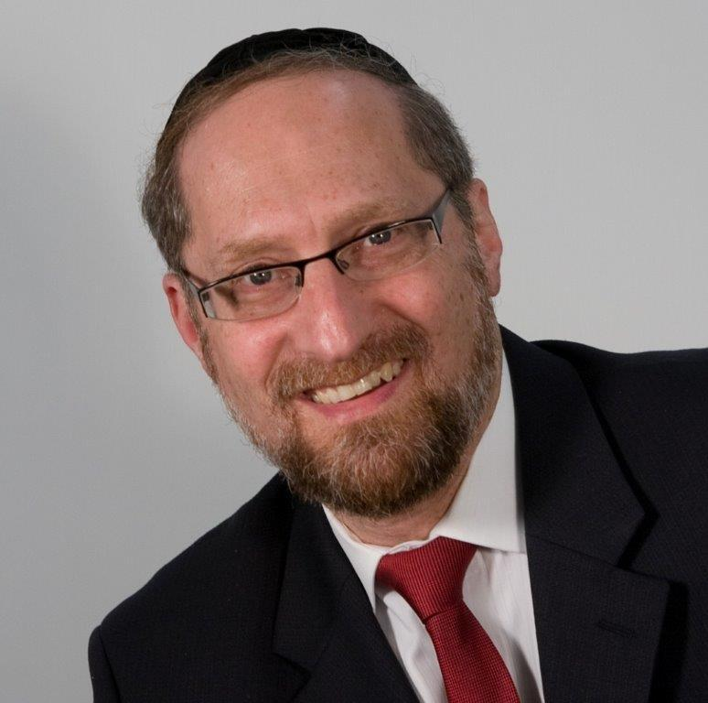

*“When you build a new house, you shall make a fence for the roof. Do not be responsible for the blood, because the faller will fall from it.”* Devarim 22:8

The Torah commands us in various safeguards. One is the obligation to erect a fence. If you construct a house with a flat roof, you are required to put up a fence, to prevent people from falling off.

Rashi notes that the Torah uses an unusual expression, “Because the “faller” will fall.” He is called the “faller” because he was slated to die. The Torah is telling us, that was his fate. Nevertheless, you should put up a fence, so that you aren’t the one to bring about his death. And if you don’t take the necessary precaution, then, on some level you are considered responsible for his demise.

This Rashi is difficult to understand. If this man was decreed to die, and it would have occurred anyway, in what way are you responsible?

The answer to this question is based on a deeper understanding of reward and punishment and free will.

**Outcomes and intentions**

Imagine that one day, Reuvain walks up to Shimon, pulls out a gun and says, “I’m going to kill you!”

“No. No. Don’t do it!” Shouts Shimon.

“You have this coming to you!” Reuvain, responds. He then fires five shots. Leaving Shimon dead in a puddle of blood.

If the Sanhedrin were functioning, they would gather the evidence, and convict Reuvain as the killer of Shimon.

Here is the question. Why can’t Reuvain say to the judges, “Aren’t you religious Jews? Don’t you believe that HASHEM decrees who will live and who will die? If you do, then I’m not Reuvain’s killer—HASHEM is. If it wasn’t slated to happen, I could never have done it. So don’t go blaming me.

**Why isn’t his claim valid?**

The answer is thaton on one level his claim is a hundred percent correct, but it won’t get him off the hook.

The foundation of bitachon is understandingthat, “*No person, animal or other creation can harm me, without Hashem’s approval*” (*Chovos HaLevovos*, *Sha’ar* *HaBitachon* 3). In simple terms, Hashem is there with me, 24/7, guiding my life, protecting me—and nothing can touch me, unless it is directed by Hashem. Stormy seas can’t drown me. Hurricanes can’t flood my home. Wild fires can’t burn me. Drunk drivers can’t kill me. Bears can’t maul my children. No harm can befall me, unless it was decreed by Hashem.

So if on the previous Rosh Hashanah, Shimon had a decree of a year of life, then there is nothing that Reuvain or any other force in existence could do to change that.

If, however, Shimon had a decree that this would be his last year, then things get more complicated. To allow for free will, there are times when HASHEM will allow a person the “opportunity to be the messenger”. So, if Shimon were decreed to die that year in a violent manner, HASHEM might also decree that Reuvain has the option to be the one to end his life. In that case Reuvain could kill Shimon.

If Reuvain doesn’t take the opportunity, then a drunk driver, or a falling telephone poll, or a stray bullet, or any number of other catastrophic events will hit Shimon. If, however, Reuvain does take the option, then he is called the “killer”. Even though Shimon would have died anyway, even though this decree was decided by HASHEM, for all intents and purposes he is considered Shimon’s killer.

The concept is that man controls intentions, only HASHEM controls outcomes, yet, if HASHEM allows man to act, then the results are credited to him—even though in reality he did nothing.

**This dichotomy applies to the spectrum of human interactions.**

If someone saves my life; I have to recognize that if he weren’t there, a speedboat would have pulled up, or a floating log would have suddenly passed by, or any number of other means that HASHEM might use. If someone gave me a large sum of money, I have to be mindful, that if not for him, that money would have come to me through other means.

And while I remain ever conscious of this, I have to recognize how HASHEM runs the world. If HASHEM allows that man to pull me out of the water, not only do I have to have unending appreciation for his good intentions, in many regards he is considered the one who saved my life.

This seems to be the answer to the question on Rashi. Granted this man would have fallen anyway, yet the Torah is warning us—don’t you be his killer. If you leave your roof without a fence, you have been negligent. Yes, he would have died anyway, but you acted irresponsibly, and on some level you our considered responsible for his death—the act is attributed to you.

**The foundation for trusting HASHEM**

These concepts are very applicable to our lives. On its most practical level, it means that my fate is not in the hands of man. No human being can alter my state. If I was slated to be wealthy—you can’t take that from me. If I was determined to enjoy honor—you can’t defame me. If I wasn’t supposed to suffer—you can’t cause me pain. You may dream and scheme, but Hashem is here, protecting me, guiding all outcome.

If I am to suffer, then it will happen regardless of your attempts. But if it wasn’t meant to, nothing you do can change that. Every ounce of pain and suffering is weighed and meted out by Hashem. No one can alter that.

**My relationship to you**

This perspective changes my relationships with others. If you try to help me, I am appreciative—for your intentions. You tried to help. That part—the attempt—is in your hands. If you tried to lighten my load, for that I am thankful. But the result, whether you succeed or not, is not in your hands.

So too, when you harm me. I didn’t ask you to be the nudnik to bring this about, but I understand that it would have happened, with or without you. So my anger at you is greatly dimiished. For wishing my harm, I have my issues with you. But for bringing it about, not at all. The results have nothing to do with you. Man controls his intentions; Hashem controls the outcome.

*Reprinted from this week’s website on TheShmuz.com This is an excerpt from the [Shmuz on the Parsha book](https://theshmuz.com/product/shmuz-on-the-parsha-book/).*

**The True Reward of a Jew**

**Will be in the Messianic Era**

**From the Talks of the Lubavitcher Rebbe**

**Rabbi Menachem Mendel Schneerson, Zt”l**

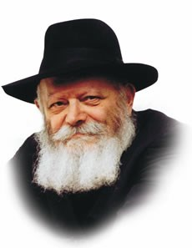

This week's Torah portion, Ki Teitzei, contains the commandment to pay a hired laborer on the same day he has worked.

"At his day you shall give him his hire; neither shall the sun go down upon it."

We, the Jewish people, are considered the "hired laborers" of G-d.

Our "task" is to observe the Torah and its mitzvot, and our "payment" is the reward G-d grants us for having obeyed His will.

A general principle in Judaism is that G-d Himself performs the same mitzvot He commands us to observe. If we are forbidden to delay paying our employees until the following day, G-d too is required to "pay" every Jew immediately upon the performance of a mitzva. Yet the Torah also states, "Today is for observance; tomorrow (the World to Come) is for receiving reward." Is this not a contradiction?

If one considers a Jew's entire life -- the sum total of his observance since the day he was born -- as one long workday, after which he is entitled to his reward in Gan Eden, [the World to Come] this explanation is in itself insufficient.

For the true reward for observance of Torah and mitzvot is not granted in the afterlife in Gan Eden, but in the Messianic Era, when the dead will be resurrected and live once again in a physical body.

The reward a Jew receives in Gan Eden is primarily in the merit of the Torah he studied during his lifetime; the reward for our mitzvot will come only after the Resurrection.

But how is this fulfilling the mitzva of "At his day you shall give him his hire" if we must wait thousands of years for our "payment"?

In order to understand, let us examine exactly what our Divinely-appointed job entails.

According to the Torah, this physical world was created solely because "G-d desired a dwelling place down below."

Precisely here, in a coarse material world that obscures the holiness within, G-d wants His Presence to be revealed.

The task of transforming the world into a suitable dwelling place for G-d is a collective one, spanning the generations since the beginning of time.

Every mitzva that a Jew performs refines his body and purifies the world at large, gradually infusing the material world with G-dliness.

Over the thousands of years of the world's existence this holiness has accumulated, readying the world for its ultimate perfection -- the revelation of Moshiach and the Messianic Era.

The "contract" between G-d and His people is not that of an employer and his day laborer. Rather, the Jewish people has undertaken the collective charge of preparing the world for Moshiach, an undertaking that is not the responsibility of one individual, but is the duty of all Jews, throughout the generations.

The full reward for our efforts will be granted only when the job is completed and Moshiach is revealed, speedily in our day.

Even now, however, during the last minutes of exile, G-d is obligated to ensure that all the needs of his "laborers" are met, so that we may properly attend to the task at hand and hasten the immediate Redemption.

*Reprinted from the Parashat Ki Teitzei 5754/1994 edition of L’Chaim Weekly (Issue #331), a publication of the Lubavitch Youth Organization in Brooklyn, NY.*

**Rav Avigdor Miller on the**

**Shas You May Never Use**



**QUESTION:** The Rav said during the shiur last week that people should buy a *shas,* a set of the *talmud*, for their homes even if they won't use it. Can you explain the reason for that? And does it apply to an unmarried bochur as well?

**ANSWER:** A *shas* is really an ornament. It's a most beautiful ornament for the Jewish people. And that's why it sometimes comes beautifully bound, and it's printed on nice, strong paper. It's our pride and joy, the *shas*.

Especially if you won't use it, it will remain handsome always. And you should be proud of your *shas*. When visitors come in, you show it to them, and they say, "What are these big volumes?" And you can tell them that the *shas* is the pride and joy of the Jewish nation.

I was once in a man's house, and he took me into his room where he had his coin collection. He was so proud! He was showing me his African coins, and his Chinese coins. What is there to be proud of?! I don't see anything in it. But when a man is proud of something, he shows it off.

The *Talmud Bavli,* now that's a collection! It's the masterpiece of our nation. Isn't it beautiful? It's a beautiful ornament to have on your shelf. Even if you don't read it, it's a masterpiece and it's something to talk about. It's a showpiece for your visitors. Take out the volumes and show them, "Look at this. And look at this one. Isn't it beautiful?!" The wise man is proud of the things that are worthy of pride. And the fool is proud of his African coin collection.

The only question is: Suppose you are an unmarried young man, and you hope to get married eventually; so should you buy one right now, or should you wait for your future father-in-law to buy a set for you?

I would answer as follows: Would you buy a bedroom set right now? No, you wait until you are married. So when you buy all your furniture, then you buy a *shas* as well. A *bochur* has to keep moving; sometimes he has to go from one yeshiva to another. So you can't have a *shas* around your neck and anchor yourself down.

So wait until your father-in-law comes along and buys you a *shas*, a set more expensive than you could afford anyhow. And when you do finally put that *shas* on the bookshelf, you must know that it is the pride of the Jewish people.

*Reprinted from the September 6, 2019 email of Toras Avigdor, based on Tape #817.*

**Rabbi Berel Wein on**

**Parashat Ki Seitzei**

This week’s Torah portion deals with many different issues of human behavior and family relations. We are all aware that the relationships between parents and children, as well as between other relatives in the same family are often difficult ones and fraught with potential danger, frustration and even tragedy. People within a family are very capable of disliking and even hating one another despite their biological and social connection. This is because in the basic family structure there exists a bond of love between the members of the family that is natural and quite strong. And any time strong love is present, the possibility of strong hate always lurks in the background.

Precisely because children love their parents, they feel justified in holding them to unrealistic standards of behavior and attitude. And since parents often fall short of such absolute perfection, the resentment towards them can become so great as to lead to awful family disputes.

Hard statistics reveal that most murders occur between perpetrators and victims who are related or know each other well. These family members have experienced disappointment and often complain of severe mistreatment.

There are many current theories as to how to properly raise children and create tranquility and harmony within the family unit. But, as is true in almost all areas of life, one size does not fit all, and it is difficult to fit each separate case into any general rule. Because of this, it is obvious that every family must sort through relationships and affairs individually. Very rarely if ever can any outside source, no matter how wise or professional, solve the problems and workings of the family unit.

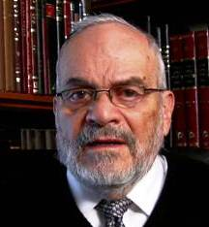

**Rabbi Berel Wein**

From the narrative that appears regarding the rebellious son – a narrative that according to one opinion in the Talmud is to be treated only as a metaphor – it is clear that we are being taught that there are instances when no logical or rational solution is present or possible.

It is difficult for us in our time, when we have unlocked so many doors regarding the mysteries of science, technology and medicine to have to admit that there are basic human problems that exist within family relationships that we are powerless to solve on our own.

Later in the Torah we will read that that there are many hidden things in human life that only Heaven can deal with. We can only do the best that we can, to the extent that we are physically, emotionally and intellectually able. There is no question that this limitation upon our omnipotence is very frustrating especially to modern humans who believe that they are capable of everything.

By realizing that paradoxically we can accomplish more than we thought possible in times of difficulty, eventually we know that we must rely upon the G-d that infuses us with life, to help us solve all difficult situations and to accept G-d's will.

*Reprinted from this week’s website of Rabbiwein.com*

**18 Ways to More**

**Effective Prayer (Part 6)**

**By Rabbi Moshe Meir Weiss**

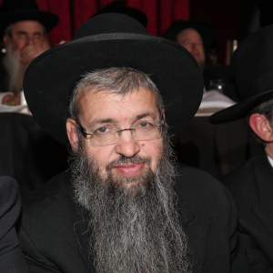

Once again, we continue our crash course on skillful prayer.

**Effective Way Number Seven:**

One’s prayers are always heard by Hashem when one davens in a minyan. On the other hand, when one davens in the privacy of one’s home, he is not assured to get an audition from Hashem. This is based on a derivation from two contradictory pasukim.

One verse says, “Mi kaHashem Elokeinu? B’chol kareinu eilav – Who is like Hashem our G-d? Whenever we call Him, He is available to us.” Yet another verse says, “Dirshu Hashem bhi’matza’oh – Seek out Hashem when He can be found,” wherein the Gemora teaches us that He is only for certain available during the Aseres Yomei Tshuva, the Ten Days of Repentance.

The Gemora explains that the second verse is talking about when someone davens alone. Then, he is only guaranteed an audience during the Ten Days of Repentance. The first verse is talking about when one davens with a minyan. With a minyan, he is assured that Hashem is definitely listening to him, at any time during the year.

When Yakov Avinu had the famous dream of the ladder, it says, “Vayikatz Yaakov mishnaso, vayomer achein yeish Hashem bamakom hazeh v’anochi lo yadati – And Yaakov woke up from his sleep and said, Behold Hashem is present in this place and I did not know.”

One of the Rishonim, the Panei’ach Raza, reveals that the last letters of the words vayikatz Yaakov mishnaso vayomer are tzadik, beis, vav, reish, which spell the word tzibor, a congregation of ten. Thus, the posuk is revealing that there is always the special Presence of Hashem amongst ten men.

**Effective Way Number Eight:**

When it is not possible to daven with a quorum, it is still helpful to daven in shul rather than davening at home. As the Gemora says, “B’makom rina sham t’hei tefilah – In the place of song, there should be one’s prayer.”

**Effective Way Number Nine:**

One should always try to pray in the same place. Of course, in shul one should have a makom k’vuah, a fixed place to pray, but one should designate a specific place to pray even in one’s home. This is true for women as well. There are multiple reasons for this.

First, the Gemora in Berachos teaches us that we learn it out from Avraham Avinu for by him it says, “Vayashkeim Avram el hamakom asher hu omeid sham – When Avram got up to the place where he had stood before.”

Second, our tefilos are substitutes for the karbonos, the sacrifices which were offered on the mizbei’ach, the altar, which had a fixed position in the Temple. Therefore, now too we should have a fixed position for our prayers.

Third, the mefarshim explain that if we keep on davening in different places, we are not used to the surroundings and they will distract us. But, if we always daven in the same place where we are used to our surroundings, they won’t provide a distraction to our concentration.

In the merit of sharpening our prayers, may Hashem listen to our supplications and bless us with long life, good health, and everything wonderful.

*Reprinted from the Parshas Shoftim 5779 email of the Jewish VUES.*

**In Orthodox Jewish Brooklyn, a Spate of Assaults Feels All too Familiar**

**By Ben Sales**

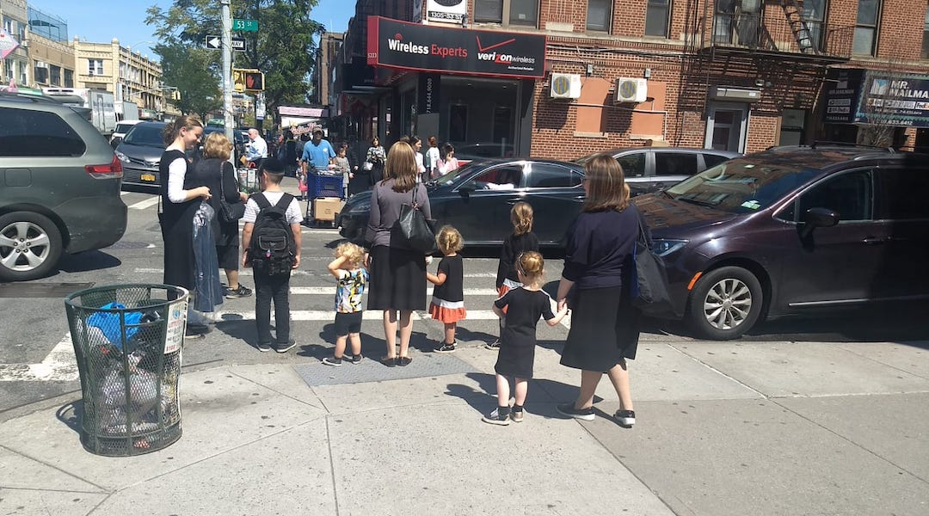

**Women and children wait at a crosswalk in the Orthodox neighborhood of Borough Park, Brooklyn, Sept. 3, 2019. (Ben Sales)**

NEW YORK ([JTA](http://www.jta.org/)) — As he talks about the recent string of attacks on Orthodox Jews in Brooklyn, Yosef Rapaport points to a small scar above his right eye.

It’s the remnant of an anti-Semitic attack he experienced 50 years ago as a teenager in Montreal.

“For those of us who look very Jewish, this has been a constant,” said Rapaport, 65, wearing a black hat and suit, as he stood outside an afternoon prayer service in the heavily Orthodox Brooklyn neighborhood of Borough Park. “You shrug your shoulders. It’s like a constant background.”

That same afternoon, New York City’s new Office for the Prevention of Hate Crimes opened months ahead of schedule. The timeline was advanced in part because of a recent string of attacks on visibly Jewish people in Brooklyn.

At least three came in a week:

* On Aug. 31, an assailant hit a Jewish man with a belt outside a synagogue.

* On Aug. 29, an assailant threw rocks at a Jewish man while the victim was in his truck.

* On Aug. 27, a Jewish man was struck with a paving stone as he exercised in a park.

According to New York Police Department [statistics](https://www1.nyc.gov/site/nypd/news/p0604b/city-achieves-new-record-low-may-murder-shooting-incident-categories#/0) from early June, there have been 110 hate crimes against Jews in 2019, ranging from assaults to anti-Semitic graffiti. That’s nearly double the previous year’s figure.

“We won’t tolerate hatred or violence against our Jewish community,” Mayor Bill de Blasio tweeted on Aug. 30, the day after the rock-throwing attack.

“It’s scary because we live a good life here, and we want to live in peace and tranquility so we can be able to serve G-d to the best of our abilities,” said Sarah, a life coach in Borough Park who is the daughter of Holocaust survivors. She declined to give her last name.

“We don’t want to be disturbed by fears,” Sarah said, “and it brings back memories of what our parents had to go through.”

The violence has led to a spate of [editorial comment in the Jewish media](https://www.tabletmag.com/jewish-news-and-politics/287821/orthodox-jews-attacked-brooklyn-hate-crime) saying the [attacks are going underreported](https://forward.com/opinion/430446/why-does-no-one-care-about-violence-against-orthodox-jews/) because law enforcement refuses to see them as hate crimes or [secular Jewish organizations don’t relate to the challenges facing Orthodox Jews](https://www.jns.org/opinion/the-true-face-of-american-anti-semitism-is-primarily-anti-orthodox/).

But for some in Borough Park, life feels the same. They said daily rhythms haven’t changed and, by and large, the residents feel just as safe as they have in recent years. Sadly and paradoxically, they said, identifiably Orthodox Jews have always experienced hateful attacks. Some said there’s a focus on the Brooklyn attacks because of a documented rise nationally in anti-Semitism.

“I wouldn’t say it’s a huge increase, no,” said a supervisor for the Shomrim, a private Orthodox volunteer security organization that coordinates with the New York Police Department. He did not give his name because of a Shomrim policy that prohibits speaking to the media. Shomrim has taken an active role in documenting the recent assaults and helping victims, and finds security camera footage to assist police.

“These kinds of incidents had been happening before,” the supervisor said. “Regarding anti-Semitism, it’s been happening before also, but in a way every incident is being looked at now differently because everyone’s mind is on anti-Semitism now.”

The supervisor said Shomrim has not stepped up its patrols nor made a move to increase its ranks, though he said patrols are on alert for assaults. He added that it’s unclear whether every attack on a Jewish person or institution qualifies as anti-Semitism.

“What we do see is an increase in assaults,” he said. “If it’s anti-Semitism, I can’t tell you. It looks like anti-Semitism when you watch a video. Is it actually anti-Semitism? Who knows?”



**Yosef Rapaport, left, and his son Alexander do not feel that life has become more dangerous for Orthodox Jews in Brooklyn. They say attacks on Jews are nothing new. (Ben Sales)**

That view was echoed by others in the neighborhood, who said they did not feel unsafe.

“The trends overall are overwhelmingly good,” said Sholom, 34, a father of six who lives in Lakewood, New Jersey, and works in Borough Park. “Like, we live in the best, safest times ever. Are you going to have incidents that are unfortunate? Sure. Are you going to have blips? Sure. Does that mean that the next Holocaust is coming? I don’t think so.”

Local politicians are still urging action to combat the rise in hate crimes.

City Councilman Chaim Deutsch, who chairs the council’s Jewish caucus, applauded the opening of the hate crime prevention office and called for further education to combat hate. He also secured $2 million to fund security cameras in his south Brooklyn district and has worked to increase mental health services in areas that have experienced hate crimes.

“It’s very concerning and very disturbing to me,” he told the Jewish Telegraphic Agency. “It’s irrelevant if it’s been happening in the past. The main impact of this is what’s happening in the present.”

Agudath Israel of America, an umbrella haredi Orthodox organization, has advocated for government security funding for synagogues and other Jewish institutions. Leah Zagelbaum, the group’s vice president of media affairs, said she personally feels that it’s good that the attacks are getting more attention.

“Crimes against Orthodox Jews do not get the attention they deserve from any quarter,” she said, clarifying that she was speaking in a personal capacity. “I think turning the light onto reprehensible behavior, and education, is good.”

But some are skeptical that the attacks can end. Alexander Rapaport, a Borough Park resident and the executive director of the Masbia Soup Kitchen Network, agrees with his father Yosef that anti-Semitic attacks are a longstanding reality for Orthodox Jews and wondered how it is possible to combat an age-old hate.

“An average visible or identified Jew was harassed just as much in 2003 and 2006 and 2007 and 2015,” he said. “What else can you do other than find the perpetrators and prosecute them?

“When you say take action, what is really the action? Hate is something in your mind. How do you counter that?”

*Reprinted from the September 3, 2019 dispatch of the JTA (Jewish Telegraphic Agency)*

**A Fifth Serving of the Book**

**Of Amazing Facts & Feats**

**By Daniel Keren**

(“The Book of Amazing Facts and Feats: The Creator’s World and All That Fills It” by Nattan Hurvitz and Aharon Yosef Hoffman, translated from the Hebrew Sefer HaSe’em v’HaNifla’ot, volume 5 by Brocha David with research by Yitzchak Hurvitz and graphics and design by Sarah Indig; Feldheim Publishers, 160 pages coffee table hardcover, 2019)

There are many sources that teach us that G-d created a physical world in which His direct presence would be in a concealed form in order to allow his human creations the opportunity of bechira, free will and the chance to earn reward by clearly discovering Hashem’s presence on their own if only utilizing their common sense and behaving according to the Divine will as prescribed in the Torah.

Rabbi Avigdor Miller was famed throughout the world for marveling about the wonders or niflaot of Hakodesh Baruch Hu, such as the seemingly simple apple seeds or the coloration of the fruits and vegetables that can be found in our daily world if only we open our eyes.



According to some Chassidic masters, the whole purpose of Hashem’s creating this world from nothing was to give mankind, the pinnacle of His creation the opportunity to transform the mundane into the realm of the holy and make G-d’s presence more revealed.

Feldheim has just published the fifth volume of “The Book of Amazing Facts and Feats: The Creator’s World and All That Fills It.” The authors in their brief preface conclude by writing “It is our hope that this information-packed journey will inspire us all to be a little wiser about the choices we make so that each and every one of us can improve ourselves and make a positive contribution to Hashem’s incredible world.”

Anyone can by googling Wikipedia come up with a ton or more of fascinating trivia about the world that surrounds us. But what makes this and the previous four volumes of “The Book of Amazing Facts and Feats” stand out so much as a coffee book that you might want to give as gifts to family and friends is the extra effort in finding photos and illustrations to accompany the text.

I won’t say that all the facts and feats discussed in this latest volume 5 are in my opinion amazing. Many are just simply freaky or the type of stuff that you think of each morning when you thank Hashem for not making you a goy or a Jew who is too fascinated with the mishugas (craziness) of the non-Torah world around us.

This new volume is broken up into eight sections: (1) Food for Thought, (2) Treasures, (3) Cemeteries, (4) That’s Wild, (5) Give it a Shot, (6) Something from Something, (7) What on Earth? and (8) Eretz Yisroel.

The section or chapter that I found most interesting was the first on Food that tackles the transformation in our eating habits over the last 100 years from natural to processed foods, the history of cookbooks, the Israeli kitchen, the topic of hummus, royal delicacies through history, everything you want to know about meat (unless you’re a vegetarian), fast food, snacks, and the New World food of corn.

The book offers you two pages on wacky wealthy personalities who left millions of dollars to their pet dogs and cats along with photos of those “lucky” dogs. One perhaps not-so-surprising hint is that not of those who made such wills were Torah observant Jews.

For those of you who have problem sleeping at night because of fear of global warming, you will want to read the section “What on Earth?” that includes many pages chockful of photos dealing with the growing problem of worldwide waste in garbage, spoiled food and electronic and radioactive waste.

If you have a tremendous curiosity about Mt. Hermon, Israel’s tallest mountain you’ll definitely want to read pages 146-149. In the section on Eretz Yisroel you will also discover some amazing facts about the world’s biggest bird restaurant that opens every year in the Hula Valley to accommodate that more than 100,000 cranes that fly from Africa to Europe with a pit stop in Europe and visa versa. In addition to cranes, the Hula Valley also sees visits from 500 million other birds of all types including pelicans, herons, storks and predatory birds.

Other pages at the end of the book on Eretz Yisroel reveal intriguing details about the unique Ramon Crater, Lake Kinneret, the Jordan River and the Dead Sea.

Obviously not every selection in “The Book of Amazing Facts and Feats” will astound you. But I am sure that you will find many that you will enjoy telling over to family and friends at your Shabbos table and perhaps in shul while waiting for the davening to begin or for a shiur to commence. “The Book of Amazing Facts and Feats –volume 5” can be found in bookstores or online sites or by contacting the publisher be either clicking feldheim.com or calling (845) 356-2282.

*Reprinted from the September 5, 2019 edition of the Jewish Connection.*